Scan the Server 1:

Step 1: Open the lab link to access the Kali machine.

Step 2: Check if the target machine is reachable:
Command:
ping -c 4 demo.ine.local
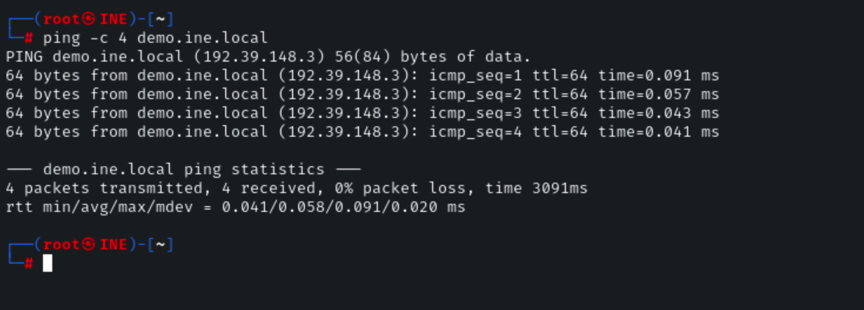
/
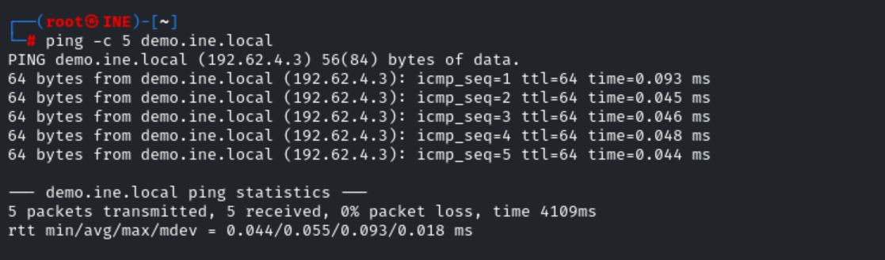
The target is reachable.
Step 3: Port scanning with Nmap
We can now perform a default Nmap port scan on the target to identify the open ports on the target system, this can be done by running the following command:
Command:
nmap demo.ine.local
As shown in the following screenshot, the default Nmap scan does not reveal any open ports. This is because the default Nmap scan profile only scans 1000 of the most commonly used ports.
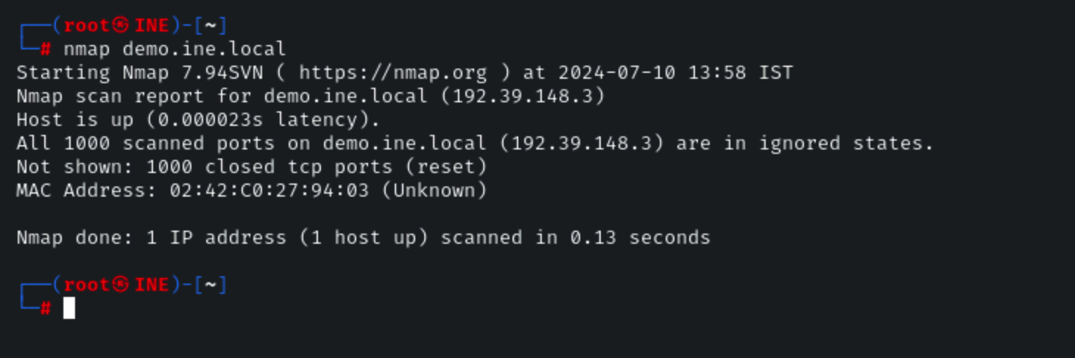
/
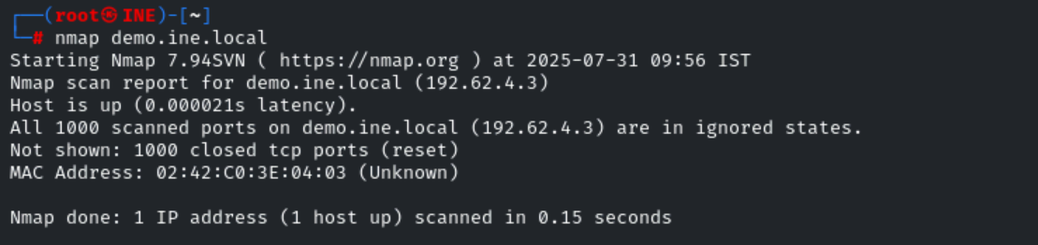
In order to get an accurate idea of the open ports on the target system, we will need to scan the entire TCP port range (65,535 ports). This can be done by running the following command:
Command:
nmap demo.ine.local -p-
As shown in the following screenshot, the Nmap scan reveals that the target system has 3 open ports.
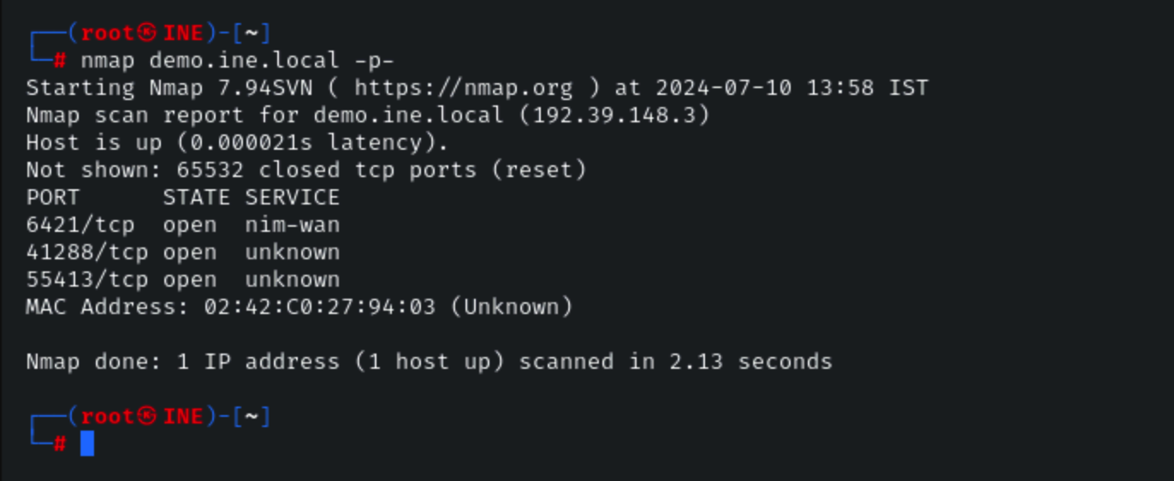
/
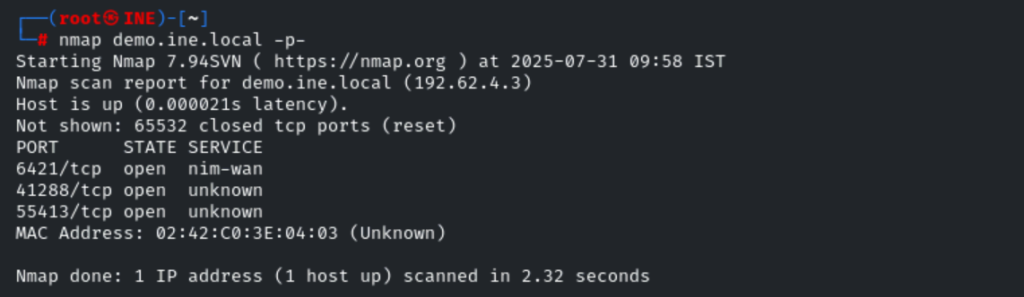
Step 4: Service detection with Nmap
Now that we have identified the open ports on the target, we can learn more about the services running on the open ports by performing a service detection scan with Nmap.
This can be done by running the following command:
Command:
nmap demo.ine.local -p 6421,41288,55413 -sV
As shown in the following screenshot, the Nmap service detection scan reveals the names and versions of the services running on the open ports on the target system.
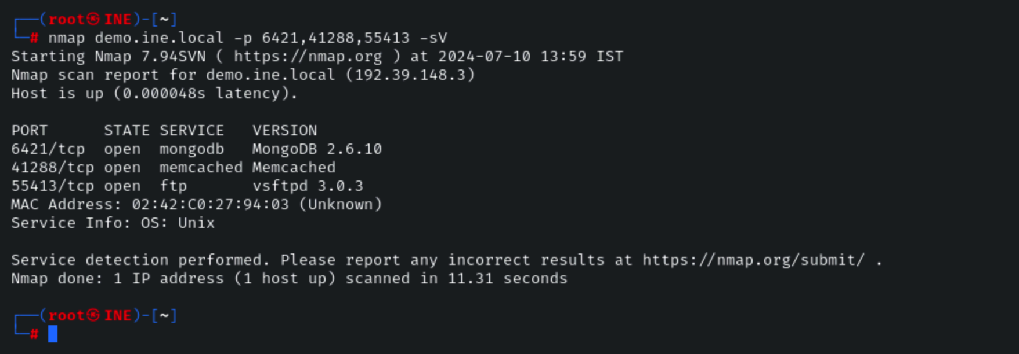
/
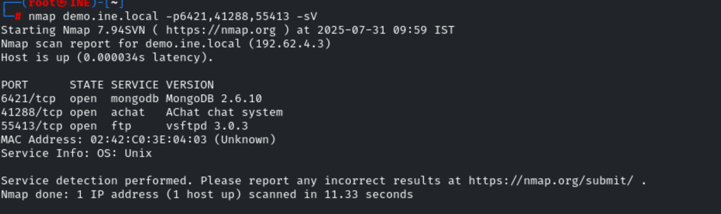
Conclusion
In this lab, we explored the process of performing port scanning and service detection with Nmap.

